Development of High ……………….Brassica rapa Genome Sequencing Project
Title: Font, Times New Roman;
Size, 14; Style, Bold; Location, Center
Capitalize the first letter of all title words.
Authors: Font, Times New Roman;
Size, 12; Style, Plain; Location, Center
If the affiliations are different, please classify by asterisk.
Xiaonan Li¹, Nirala Ramchiary², Su Ryun Choi³, Md. Jamil Hossain⁴, Hyeon Kook Yang¹, YongPyo Lim^{1*}

¹ Department of Agricultural Resource Economics, Faculty of Agriculture, Kyushu University,
Hakozaki 6-10-1, Higashi-ku, Fukuoka city 812-8581, Japan
Affiliations: Font, Times New Roman; Size, 10.5; Style, Italic; Location, Center
If the affiliations are different, please classify by asterisk.
²Division of Bio-Resource Sciences, College of Agriculture and Life Sciences,Kangwon National University,
Chuncheon 200-701, Korea
³
Corresponding author: Font, Times New Roman; Size, 10.5; Style, Bold; location, Center. The corresponding author should be noted by an asterisk.
⁴
Email: Font, Times New Roman; Size, 10.5; location, Center.
*Corresponding author: xxxx@cnu.ac.kr

Abstract. A high density integrated linkage map was constructed in B. rapa by combining CKDH reference genetic map developed using ….
Abstract:Font, Times New Roman; Style, Bold; Size, 12
Text: Font, Times New Roman; Size, 11
Don’t put any figures and tables into abstract.

Line number: Continuously numbering, Do not restart each page

Margins: Left and right sides, 2.0 cm
Top, 2.5 cm
Bottom, 3.0 cm

The information including title, authors, affiliations, text, keywords, and corresponding author, must put into 1 page.

…. Multinational B. rapa Genome sequencing project (MBrGP).

Additional key words: simple sequence repeats (SSR), ….5-6 keywords

Keywords: Font, Times New Roman; Size, 11; Style, Italic

Page numbers: Position, Bottom of page; Alignment, Center
Introduction
Introduction: Font, Times New Roman; Style, Bold; Size, 12; Location, Center
Recently, there has been an increase in market demand for the extension of storage period of domestic table grapes to supply fresh grape all year round with complementary effects of imported fresh table grape market. Studies of storage potential for two major table grape cultivars, ‘Campbell Early’ and ‘Kyoho’, indicated relatively short storage period (Weeks et al., 1994; Kim, 1999, 2014a, 2014b; Vannini and Chilosi, 2014).
Text: Font, Times New Roman; Size, 11; 2.0 space, Indentation, First line 2.5 ch
….. ….. ….. ….. ….. ….. ….. ….. ….. ….. ….. ….. ….. ….. ….. ….. ….. ….. ….. ….. ….. ….. ….. …..….. ….. ….. ….. ….. ….. ….. ….. ….. ….. …..
From page 2, please start Introduction.
When you insert figures and tables, please make them clear in color or black-white printing.

Subtitle: Font, Times New Roman; Size, 11; Style, Bold; Location, Left
Materials and Methods: Font, Times New Roman; Size, 12; Style, Bold; Location, Center

Materials and Methods
Strains and Cultivating Conditions
Thirteen isolates of P. infestans Mat-A2, fourteen isolates of P. infestansMat-A1 (Table 1), …..….. ….. ….. ….. ….. ….. ….. ….. ….. ….. ….. ….. ….. ….. ….. ….. ….. ….. ….. ….. ….. ….. …..….. ….. ….. ….. ….. ….. ….. ….. ….. …..
Text: Font, Times New Roman; Size, 11; 2.0 space; Indentation, First line 2.5 ch

Extraction of Genomic DNA and AFLP Analysis
The genomic DNA of P. infestanswas extracted by modification of the methods
described by Goodwin et al. (2003)….. ….. ….. ….. ….. ….. ….. ….. ….. ….. ….. ….. ….. ….. ….. ….. ….. ….. ….. …..
Results: Font, Times New Roman; Size, 12; Style, Bold; Location, Center
Results
….. ….. ….. ….. ….. ….. ….. ….. ….. ….. ….. ….. ….. ….. ….. ….. ….. ….. ….. ….. ….. ….. ….. …..….. ….. ….. …..
Discussion: Font, Times New Roman; Size, 12; Style, Bold; Location, Center
Acknowledgement: Font, Times New Roman; Style, Bold; Size, 11

Discussion
….. ….. ….. ….. ….. ….. ….. ….. ….. ….. ….. ….. ….. ….. ….. ….. ….. ….. ….. ….. ….. ….. ….. …..….. ….. ….. …..

Acknowledgement:This study was supported by TDPAF MFAFF/iPET through Grape Research Project Group.
Literature Cited: Font, Times New Roman; Size, 12; Style, Bold; Location, Center

Literature Cited
All literature cited should be listed in an alphabetical order, by the author’s family names. For the same author, or for the same set of authors, literature cited should be arranged chronologically. If there is more than one publication in the same year for the same author(s), the letter a, b, c, etc. should be added to the year

Garcia-Hernandez M, Berardini TZ, Chen G, Crist D, Doyle A, Huala E, Knee E, Lambrecht M, Miller N, Mueller LA, et al (2002) TAIR: a resource for integrated Arabidopsis data. Funct Integr Genomics 2:239-253
Chen WH, Zhao XM, van Noort V, Bork P (2013) Human monogenic disease genes have frequently functionally redundant paralogs. PLOS Comput Biol 9:e1003073
Vannini A, Chilosi G (2013) Botrytis infection: grey mould and noble rot. In F Mencarelli, P Tonutti, eds, Sweet, Reinforced and Fortiﬁed Wines: Grape Biochemistry, Technology and Viniﬁcation. Wiley-Blackwell, Chichester, UK, pp 159-169
Text: Font, Times New Roman; Size, 12; Indentation, Hanging 1.3 ch
Table 1: Font, Times New Roman; Size, 12; Style, Bold

Table
Table 1. Comparative analysis of leaf and flower characteristics of new variety Cymbidium ‘White Girl’, its female parent C. ‘Yakoto’, and its male parent C. Lucky Rainbow ‘Lapin Hot’, at Suwon, Korea, 2000-2005.

Characteristic | ‘yyy’ | zzz | ‘ccccc’
Plant  Size | xxx | yyy | zzz
Vigor | xxx | yyyy | zzz
Habit | xxx | yyyyyy | zzz
Leaf
Shape | xxx | yyy | yyy
Length (cm) | 76.5 ± 9.1 | 84.7 ± 10.1 | 56.9 ±6.8
Width (cm) | 2.1 ± 0.5 | 2.2 ± 0.7 | 1.9 ± 0.4
Twisting | xxx | xxyy | zzzz
Fragrances | xxx | yyyy | zzzz
Ploidy level | xxx | yyyy | zzz

Figure
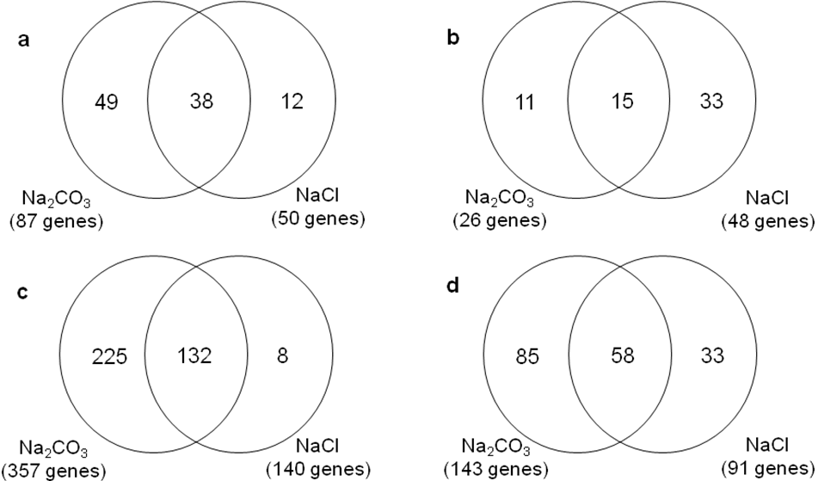
Figure parts should be denoted by uppercase letters (A, B, C, etc) instead of a, b, c, etc.
A
B
C
D
Fig. 1. Na₂CO₃ and/or NaCl stress-induced genes in leaf and root identified by microarray analyses: genes upregulated in leaf (A) and root (B); genes downregulated in leaf (C) and root (D).
Fig. 1: Font, Times New Roman; Size, 12; Style, Bold

Text: Font, Times New Roman; Size, 12; Indentation, Hanging 1.3 ch

